**FUNCTIONAL SPECIFICATIONS**

**Snap N’ Eat Mobile Applications (Android and iOS)**

**Version 3.0**

**VERSION HISTORY**

|  |  |  |  |
| --- | --- | --- | --- |
| Version No. | Description | Prepared By | Release Date |
| 1.0 | Initial Draft | HK Lance | 20151214 |
| 2.0 | Changes based on 1.0 functions | HK Lance | March |
| 3.0 | Updates based on Spec 2.0 | Gary | 2016-07-06 |

**TABLE OF CONTENTS**

**A: Setup**

A0 - Splash Screen

A1 - Starting Page

A2 - Registration Page

A3 - Login Page

A4 - Login with Social Account

A5 - “Password Reset” page

**S: Home**

S1- “Home” page

M - Menu Bar

S2 - “Search” page

S3 - Search > More District

~~S4 - Search > More Spending~~

S5 - Search > More Dish Type

~~S6 - Search Result > Food & Hashtag~~

S7 - Search Result > User

S10 - Snap Details

S10A - Share Snap Dialog

S10B - Notification (device home screen)

S11 - Restaurant Details

S12 - New Post  
 S12A - New Post > Add Photo

S13A - Restaurant List

**P: User Profile**

P0 - My Profile

P1A - My Profile > Avatar Change

P1 - My Profile > Snap Feeds

P2 - My Profile > Favorite

P3 - My Profile > Footprints

P4 - My Profile > Gallery

P5A - My Followings

P5B - My Followers

P5C - My Posts

P1B - Other Profile

P1C - Other Profile > Action Dialog

[P6 - “Report” page](Report#_P6_–_)

**A: Account Settings**

A6 - Settings

A7 - Settings > My Account

A7A - Settings > My Account > Avatar Change

A8 - Settings > Social Account

A10 - Settings > About

A11 - Settings > Disclaimer

A12 - Settings > Password Change

A13 - Settings > Language

A15 - Settings > Push Notifications

A16 - Settings > Help

**Others**

C - Camera Dialog

T - Tutorial

~~G1 - GPS Dialog~~

G - GPS Location

# **A0 - Splash Screen**

It is splash screen for APP. Apply when users launch the APP.

**Figure A. Splash Screen**



Loading Animation

**[NOTE]**

1. When APP launches:

* Apply APP language based on system language for guest user.
* Apply last used APP language for registered user.

1. Set default language is English in case the system language is neither English nor Chinese.
2. During processing on any background data, initialization or loading, apply Android/iOS standard loading animation.
3. Launch duration should be less than 2-seconds time for a good performance (when on Live server)

# **A1 - Starting Page**

Page for login, sign up or exploring as guest. This page always launches for except the user has already logged on the app and session is remembered.

**Figure 1. Starting Page**

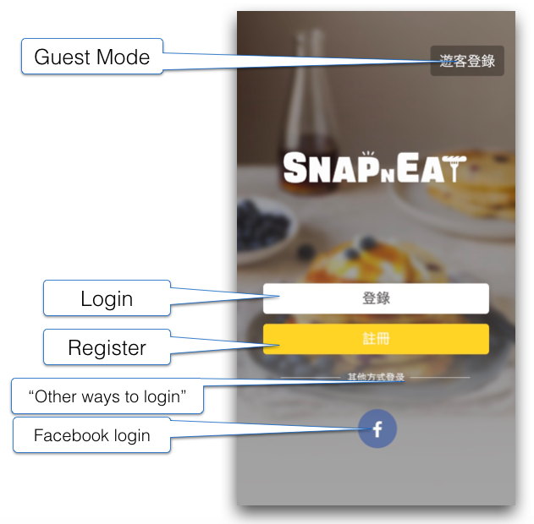

|  |  |  |
| --- | --- | --- |
| **Label** | | |
| S/N | Labels | Description |
| 1 | Login with | Section Name |
| **Button** | | |
| S/N | Name | Description |
| 1 | Login | Tap to Go to A3 – “Login” page |
| 2 | Sign Up | Tap to Go to A2 – “Registration” page |
| 3 | Facebook Login | Tap to Go to A4 - Login with Facebook |
| 4 | Guest Mode | Tap to Go to S1 – “Home” page |

# **A2 – Registration Page**

This page allows the users to register an account so that they could post Snaps. For the Email content, please follow snapneat_welcome_email.docx.

**Figure 2. Registration Page**

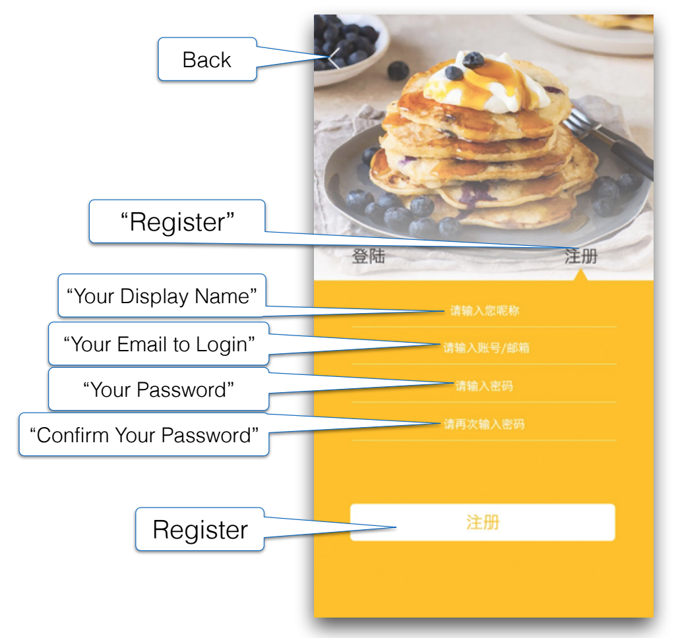

|  |  |  |
| --- | --- | --- |
| **Label** | | |
| S/N | Name | Description |
| 1 | Sign up | Page Title. |

|  |  |  |
| --- | --- | --- |
| **Text Field** | | |
| S/N | Label | Field Specific Validation |
| 1 | Email | 1. Mandatory. 2. Hint Text in Text Field and dismiss during input. 3. It is unchangeable after registration.  * APP validates if the email format is valid. * If invalid, show pop-up message. Tap “OK” to dismiss. * If valid, submit to SERVER. |
| 2 | Username | 1. Mandatory. 2. Hint Text in Text Field and dismiss during input. 3. It is unchangeable after registration. 4. Char space limits: max 24 char spaces.  * Each Chinese character = 3 char spaces. * Each alphanumeric, symbol, space & punctuation = 1 char space. * APP validates if username is valid. * If invalid (like emoji), show pop-up message. Tap “OK” to dismiss. * If valid, submit to SERVER. |
| 3 | Password | 1. Mandatory. 2. Hint Text in Text Field and dismiss during input. 3. Char space limits: 8-16 alphanumeric or symbol. 4. Any other char not mentioned above is forbidden to input.  * APP validates if password fulfill the requirement: * If password range is not between 8-16, show pop-up message. Tap “OK” to dismiss. * If password includes unsupported character (e.g. Chinese), show pop-up message. Tap “OK” to dismiss. In case Point 4 above applied, this message can be waived. * If ok, submits to SERVER. |
| 4 | Confirm Password | 1. Mandatory 2. Hint Text in Text Field and dismiss during input. 3. Rule similar to Password.  * APP validates if confirm password is same as password (S/N#3) * If different, show pop-up message. Tap “OK” to dismiss. * If ok, submits to SERVER. |

SERVER has to respond APP within 5 seconds whether the registration succeeds, or APP has to inform user if receiving no response from SERVER within 10 seconds.

|  |  |  |
| --- | --- | --- |
| **SERVER validation** | | |
| S/N | Condition | Description (pop-up message) |
| 1 | If email is used or reserved *(registered but activated)* | Show pop-up message.  Tap “OK” to dismiss. |
| 2 | If username is used or reserved *(registered but activated)* | Show pop-up message.  Tap “OK” to dismiss. |
| 3 | If username is same as any in restaurant list or dirty word list | Show pop-up message.  Tap “OK” to dismiss. |
| 4 | If registration succeeds | SERVER sends activation email to user’s email box and responds APP. APP receives response and show pop-up message. Tap “OK” to dismiss and go to A3 – “Login” page. |
| 5 | If registration failure | Whatever it is an issue caused by SERVER or APP, show pop-up message.  Tap “Cancel” to dismiss and keep the input, or Tap “Retry” to submit again. |

|  |  |  |
| --- | --- | --- |
| **Button** | | |
| S/N | Name | Description |
| 1 | Sign up | Tap to Submit request to SERVER. |
| 2 | Back | Tap to Return A1 - Starting Page. |
| 3 | Log in | Tap to Toggle to A3 – “Login” page. |

**[NOTE]**

1. This page should be implemented in a way that the Login Screen and the Registration screen is like a tab or whatever view as long as only the Login or Registration form container is replaced.
2. The registered Display Name submitted to the server should be validated against the reserved username list and prompts message to remind user for renaming.

# **A3 – “Log in” page**

It’s login page for registered user.

**Figure 3. Login Page**

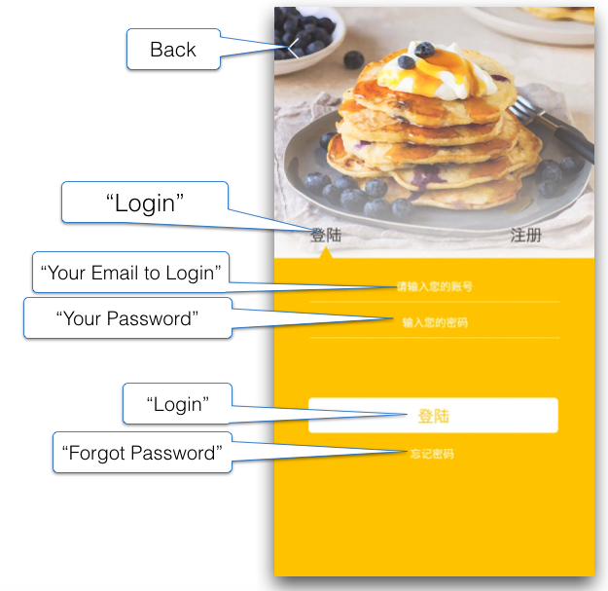

|  |  |  |
| --- | --- | --- |
| **Label** | | |
| S/N | Name | Description |
| 1 | Log in | Page Title |

|  |  |  |
| --- | --- | --- |
| **Text Field** | | |
| S/N | Name | Description |
| 2 | Email | 1. Mandatory 2. Hint Text in Text Field and dismiss during input.  * APP validates if the email format is valid. * If invalid, show pop-up message. Tap “OK” to dismiss. * If ok, submit to SERVER. |
| 3 | Password | 1. Mandatory 2. Hint Text in Text Field and dismiss during input.  * APP validates if password format is valid. * If invalid, show pop-up message. Tap “OK” to dismiss. * If ok, submits to SERVER. |

|  |  |  |
| --- | --- | --- |
| **Button** | | |
| S/N | Name | Description |
| 1 | Log in | Tap to Submit to SERVER.   1. SERVER validates if information match database.  * If no active account found, show pop-up message. Tap “OK” to dismiss. * If active account found but password incorrect, show pop-up message. Tap “OK” to dismiss * If login success, Go to S1 – “Home” page.   Remember user login until logout (not kill the app). |
| 2 | Back | Tap to Return A1 - Starting Page. |
| 3 | Forgot Password | Tap to Go to A5 – “Password Reset” page. |
| 4 | Sign up | Tap to Switch to A2 – Registration Page. |

# **A4 - Login with Social Account**

**Facebook**

This page displays the Facebook Login components from Facebook API to allow user to login with Facebook. If user wasn’t registered, login with Facebook automatically registers the new account for the user. Current Facebook profile picture will also be downloaded and uploaded to the server as the user’s avatar. Downloading of facebook profile picture is just done during 1st time login via facebook. Succeeding update of Facebook profile picture won’t update Snap n Eat avatar.

**Figure 4. Login with Facebook Page**

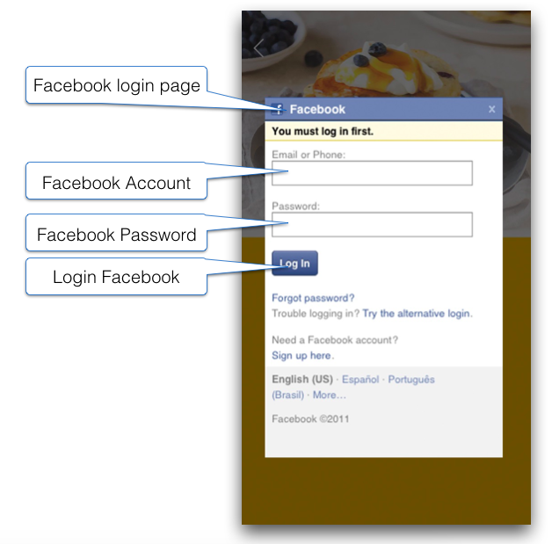

**Important Notes:**

1. Only permission to access user Email is required, this Email is to be used together with the Facebook Token as the user identifier in SnapNEat.
2. Automatically generate a “Display Name” using the the concatenated first name from Facebook trimming the space + random 6 alphanumeric characters.
3. On successful login, go to S1 Home Screen

# **A5 – “Password Reset” page**

This page allows the users to reset password if he can provide his login Email. For the Email content, please follow snapneat_changepassword.docx.

**Figure 5. Reset Password Page**

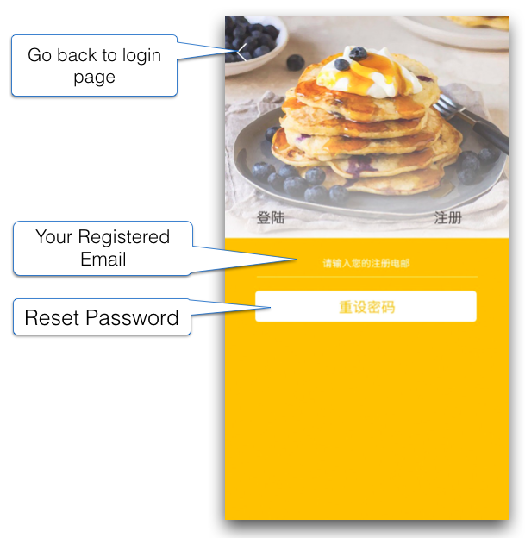

|  |  |  |
| --- | --- | --- |
| **Text Field** | | |
| S/N | Labels | Description |
| 1 | Your Registered Email | 1. Mandatory. 2. Hint Text in Text Field and dismiss during input.  * APP validates if the email format is valid. * If invalid, show pop-up message. Tap “OK” to dismiss. * If valid, submit to SERVER. |

|  |  |  |
| --- | --- | --- |
| **Buttons** | | |
| S/N | Name | Description |
| 1 | Reset Password | Tap to Submit request to server.   1. SERVER validates if the account exists.  * If no active account found, show pop-up message. Tap “OK” to dismiss. * If account found, send the new password to email and responds to APP. APP show pop-up message. Tap “OK” to go A3 – “Login” page. |
| 2 | Back | Tap to Return A3 – “Login” page. |

# **S1 – “Home” page**

It is default page to display a stack of Snaps for all users.

Menu

Hot Search

Range

Location

Add Post

Logo

Food Name

District

Rating

**Figure 6a. Home Page layout**

**Food Name**

District

Snap Card

**Username**

Avatar & Username

Share

Like & Count

~~Navigate~~ Go

The stack shown is based on the status of Location button. There are 2 modes:

1. Normal Mode (Default) – Location is OFF:

When GPS on toolbar is off, the page shows a stack of food snaps in different district. Each district contains 1 snap in a stack. Total **50** snap cards in each stack.

1. Location Mode – Location is ON:

When GPS on toolbar is on, the stack doesn’t refresh itself. It would just send the request to server and refresh once the user select the range in slide bar and release. Total **50** snap cards in each stack.

**Toolbar – S1 Home Page**

|  |  |  |
| --- | --- | --- |
| **Button / Toggle Button** | | |
| **S/N** | **Name** | **Description** |
| 1 | Menu  (Icon Button) | Tap to Open M - Main Menu. |
| 2 | Hot-Search  (Icon Button) | Tap to Go to S2 – Hot Search. |
| 3 | Location  (Toggle Button) | Tap to Toggle ON/OFF Location Mode.   * If turning it on, display pop-up message and ask for using user’s current location. (If GPS is off, direct user to System Settings if necessary) * Once Location Mode is ON, the stack is auto-updated based on the max range within “Range”, which are 100M – 1500M. * Button is disabled (dimmed) if device has no network connection. |
| 4 | Range  (Toggle Button) (Slide Bar) | Tap to Open a Slide Bar with one button below the “Range” button. And user can slide the button to select the range of searching area. Once the user releases the finger off screen, the slide bar dismisses and the request is submitted to server. Loading animation is required and the result (new stack) should be ready no longer than 5 seconds.  Mac:private:var:folders:61:4s87mdn12z5bxtk3rj1grkrw0000gp:T:TemporaryItems:aid4571607-663px-Adjust-Your-Tinder-Search-Distance-Step-3-Version-2.jpg   * Range: 100M – 1500M * Each Move: 10M * Button is disabled (dimmed) if the Location is OFF. |
| 5 | Add Post  (Icon Button) | **[Registered user]**   * Tap to Go to S12 – New Post   **[Guest user]**  Tap to Display pop-up message   * Tap “Cancel” to dismiss pop-up and remain. * Tap “Log in” to Go to A1 – Starting Page. |
| **Image** | | |
| **S/N** | **Name** | **Description** |
| 1 | Snap n Eat Logo  (Image) | Unclickable object.   * Need to be looking different to buttons above and cause less confusion to user. |

**[NOTE]**

1. Each button has 3 status (3 images):
   1. Normal (functional and user can tap)
   2. Highlighted (when button being tap or function currently ON).
   3. Dimmed (function disable and user could not tap)
2. All buttons on toolbar should be disabled without internet connection

**Snap Card – S1 Home Page**

|  |  |  |
| --- | --- | --- |
| **Label / Static** | | |
| **S/N** | **Name** | **Description** |
| 1 | Food Name/ Snap Title | Details refer to previous input in S12 – New Post.   * Display Chinese Char = max 10 and then showing ellipsis. * Display English Char = max 20 and then showing ellipsis. * Label shown at the top left of the snap card |
| 2 | District | Details refer to previous input in S12 – New Post.   * Label shown at the top right of the snap card. * Need to display full district name |
| 3 | Rating | Details refer to previous input in S12 – New Post. |
| **Button / Clickable Object** | | |
| **S/N** | **Name** | **Description** |
| 1 | Snap Card (Snap + Card in white) | Tap to Go to S10 - Snap Details.   * Either Snap or Card area (in white) is touchable.   Flick Left to Dismiss.  Flick Right to “Add to favorite”. Display temp message and dismiss message after 1 second. (Like message box when adjusting volume in iOS)   * If user flicks to direction between 0 and 120 degree (BLUE section), it must be seen as “Add to Favorite”. Otherwise it is to dismiss Card (BLUE in below). * Snap Card fade out in direction according to user’s flick.   **[NOTE]**   * Always apply Loading animation when snap cards are not ready. |
| 2 | Avatar + Username | Tap to Go to P1B – Other User Profile   * If the user account is disable or deactivated by Admin, other users can still get in P1B to explore. |
| 3 | Like  (Toggle Button) | **[Registered user]**  Tap “Like” and highlight the icon, also update the count accordingly.  Tap “Unlike” and unhighlight the icon, also update the count accordingly  Auto +1 “Like” from who upload the snap once it is uploaded and released. This user is unable to “Unlike” the own uploading snap.  **[Guest user]**  Tap “Like” and Display pop-up message   * Tap “Cancel” to dismiss pop-up and remain. * Tap “Logi n” to Go to A1 – Starting Page. |
| 4 | ~~Navigate~~ Go  (Button) | Tap to Go to G – GPS Location.   * Pin on the exact location of the restaurant. |
| 5 | Share  (Button) | Tap to Open S10A – Share dialog. |
| 6 | Refresh  (Button) | Tap to Refresh and Distribute another 20 snaps. (Only available in background when Connection Failed and Stack ends.)   * The new stack distributed depends on the Location Mode. i.e: * Distribute cards in different district when Location Button OFF; * Distribute cards in selected range when Location button ON. |
| **Message** | | |
| S/N | Condition | Description |
| 1 | Connection Failure | When enter S1-Home Page without connection:  Display message in background.   * Tap “Refresh” button to check network and get new stack. |
| 2 | Connection Failure (during exploring) | When connection failed during exploring inside S1-Home Page:  Tap any part where needs to retrieve data from SERVER, display pop-up message |
| 3 | End of stack | When it is no more snap in the stack:  Display message in background.   * Tap “Refresh” button to check network and get new stack. |

**[NOTE]**

1. Tinder like animation for Snaps Stack will be implemented:

Android (<https://github.com/kikoso/Swipeable-Cards>),

iOS (<https://github.com/cwRichardKim/TinderSimpleSwipeCards>).

Fixing the 3rd party library is not part of the scope. If during the development, the developers find that the library doesn’t work and cannot find any suitable 3rd party library to fulfill the design, it is agreed that HK will change the design to accommodate the said limitation.

1. The Snap list is only loaded/reloaded if the Home page is recreated. This only happens if the app was reopened after it was killed by the logged on user.
2. The loading time of stack should be within 6-8 seconds. If necessary, create a thumbnail for snap card, and load the full res image in S10 – Snap Details.

**Message - S/N 3**

是時候分享你的飲食樂趣！

或點 查看更多

# **M – Side Menu**

This page displays the side menu that shows on top of Home Page only.

**Figure 7a. Side Menu Layout**

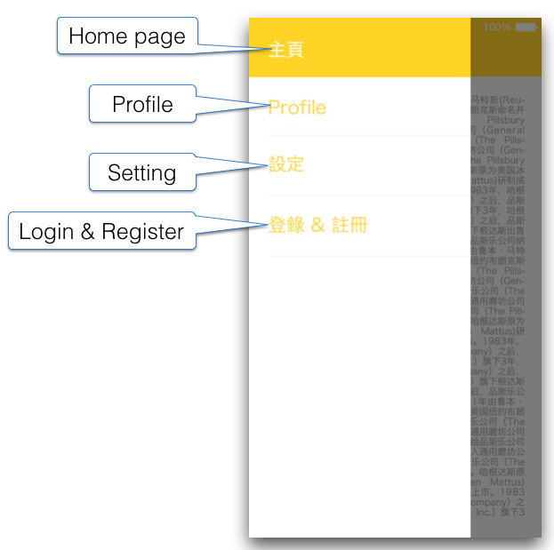

Functions in previous page disabled. Touch to return previous page

**Table 7. Side Menu Elements**

|  |  |  |
| --- | --- | --- |
| **Buttons** | | |
| S/N | Name | Description |
| 1 | Home | Tap to Go to S1 – Home Page |
| 2 | My Profile | Tap to Go to P1 - My Profile > Snap Feeds (Only available for user logged in) |
| 3 | Settings | Tap to Go to A6 - Settings |
| 4 | Log in & Sign up | Tap to Go to A1 - Starting Page (Only available in Guest mode) |
| 5 | Help | Tap to Go to A16 – Help |

# **S2 – “Search” page**

This page displays the options in a search that user can select. After done selecting the filters and search, results are displayed on another page.

**Figure 8. Hot-Search-List Page**

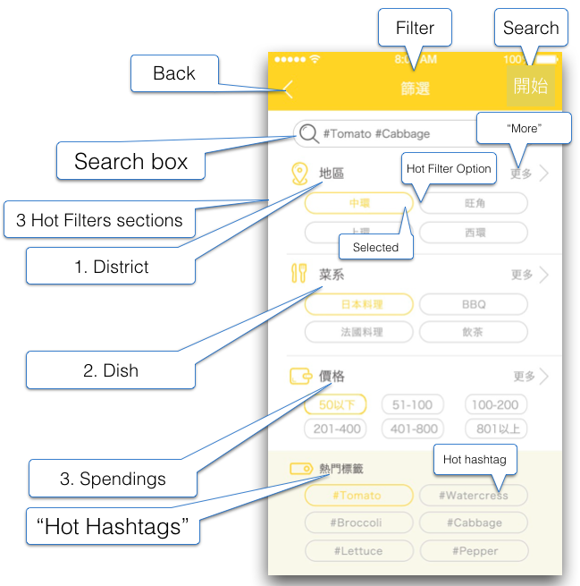

**Table 8. Hot-Search-List Page Elements**

|  |  |  |
| --- | --- | --- |
| **Labels** | | |
| S/N | Name | Description |
| 1 | Hot Search | Page Title |
| 2 | District | Section Name |
| 3 | Dish Type | Section Name |
| 4 | Spending | Section Name |
| 5 | Hot Hashtag | Section Name |

|  |  |  |
| --- | --- | --- |
| **Text Field** | | |
| S/N | Name | Description |
| 1 | Search box  (Text Field) | * Either search with # or @ * Each keyword should only contain alphanumeric and Chinese characters and an optional prefix of # or @ character. * Each keyword is separated with a space * Keywords w/o the # or @ only searches in the Snap Title field. * Keyword with # searches for tags * Keyword with @ searches for username * Hint Text |

|  |  |  |
| --- | --- | --- |
| **Buttons** | | |
| S/N | Name | Description |
| 1 | Back | Tap to Return S1 - Home Page without applying the Filters. |
| 2 | Search | * If search Food or Hashtag with prefix # (e.g. 美食), go to ~~S6 Search-Food/Hashtag Page to display search results~~ S1 - Home Page and display the results in snap cards. In case there is no result found. Display pop-up error message * If search User with prefix @ (e.g. @名字), go to S7 - Search-Result User. * If no selected filter, Search Box is empty or no filter option is highlighted, then prompts for selection * Shouldn’t allow to search for both # and @ together but allows a normal keyword and a hashed-keyword together. i.e. Allow multiple keywords for searching. |
| 3 | District  (Hot-Filter Option) | * Show the recent search of the user. * Save the search history data of the user. * Showing 6 options. |
| 4 | Dish Type  (Hot-Filter Option) | * Show the recent search of the user. * Save the search history data of the user. * Showing 6 options. |
| 5 | Spending  (Slide Bar) | * ~~The buttons found in each hot-filter sections.~~ * ~~Highlighted after clicked. Indicate this option is selected and filter also with this option on click Search~~ * ~~These options are multiple-select enabled~~   Slide Bar with 2 buttons is required instead of hot filter. Slide bar layout for reference:  Mac:private:var:folders:61:4s87mdn12z5bxtk3rj1grkrw0000gp:T:TemporaryItems:imgres.png |
| 6 | “More >”  (District)  {S2_BUTTON_01} | Tap to Go to S3 - Filter-Other-District Page |
| 7 | “More >”  (Dish Type)  {S2_BUTTON_01} | Tap to Go to S5 - Filter-Other-Dish Page |
| 8 | “More >”  (Spending) | * ~~Go to S4: Filter-Other-Spending Page~~ * ~~List of spending and hot-filter options for spending are coming from the server.~~ * ~~List can be found inside Samplerestaurantdata.xls~~   Remove “More” section, as Slide Bar covering all-range is available. |
| 9 | Hot Hashtag  (Button) | Tap to Add the selected hot hashtag to Search Box as text   * Separate with space * List of Hot Hashtags is coming fom the server. * Recent Hot search result of all users. |

**Important Notes:**

1. In each HashTag keyword should contain no space, refer to Hashtag rule
2. All the search parameters will be using “AND” logic while each of the selected “filter options” in the district, dish and spendings will be “OR”ed.
3. If user searches for user using “@” sign, it will discard all other search options specified as they are search filters for snaps.

# **S3 – Search > More District**

This page displays the list of Districts to select for the filter. Multi-selection is enabled here. For the compatibility to all other regions except Hong Kong, the settings in CMS have to be refined until it could be available for different situations.

**Figure 9. Filter-Other-District Page**

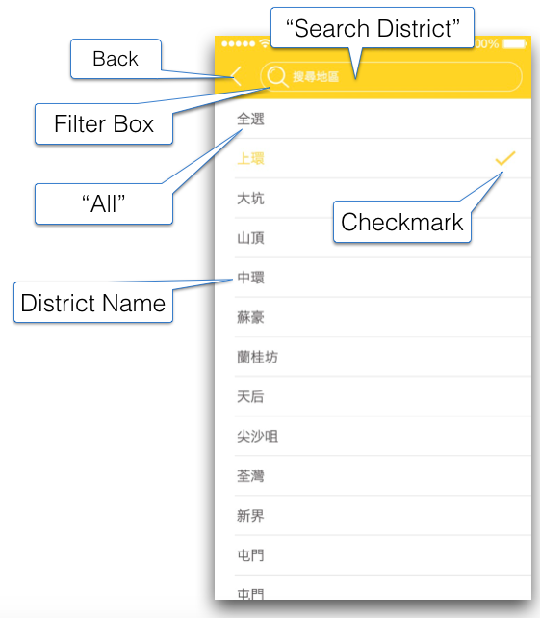

“Done” Button

“Back” Button

**香港島** –

**九龍** –

**新界 +**

**離島 +**

“Region Button: Display “-“ when expanding and “+” when collapsing.

“District”: Display in order

Done

**Table 9. Filter-Other-District Elements**

|  |  |  |
| --- | --- | --- |
| **Field Elements** | | |
| S/N | Labels | Description |
| 1 | Search District  (Text Field) | * Supports Chinese * Filter the bottom list ‘s district names which contain the inputted text * If empty text, cancel filtering |
| **Buttons** | | |
| S/N | Name | Description |
| 1 | Back  (Button) | Tap to Return S2 - Hot-Search-List without saving. |
| ~~2~~ | ~~All~~  ~~Chinese:~~  ~~全選~~ | * ~~Checkmark options~~ * ~~If “All” is checked, uncheck other checkmarks~~ * ~~If “All” is unchecked, then no districts are selected too~~   Not necessary. It shows the same result by selecting no district. |
| 2 | Done | Tap to Save the selections and Return S2 - Hot-Search-List. |
| 3 | District | * Checkmark options * Click to select * Multiple-selections allows * If checked, uncheck “All” * The districts should |
| 4 | Region  (Toggle button) | Tap to Expand/ Collapse the Region and shows the districts inside that Regions. For example  CMS has to allow the customization based on following input.   * **City** - App should be able to define the city according to the user’s physical location. All search options and result must be related to the city. This is not an option for user but Admin of CMS. * **Region** – They are the regions in the city. For example: “Hong Kong Island”, “Kowloon” in City “Hong Kong”. Shown in order in App * **District** – Data from the list of Samplerestaurantdata.xls |

**Important Notes:**

1. Change the arrow (cell’s indicator) to checkmark
2. The list of options are to be localized
3. ~~There are now 88 districts~~
4. List of options is in Samplerestaurantdata.xls > District
5. Categorize the districts, which could fulfill in further development. Please also see the requirement for CMS.
6. District must be show in order: If English, show the name from A to Z. If Chinese, show them in order 筆畫 from 少 to 多.
7. APP must be able to detect user’s location via Internet connection, and filter out the other cities but the one where user is.

# **~~S4 – Search > More Spending~~**

This page is not necessary after slide bar is applied. Refer S2 – Search.

~~This page displays the list of Spendings to select for the filter. Multi-selection is enabled here.~~

**~~Figure 10. Filter-Other-Spending Page~~**

~~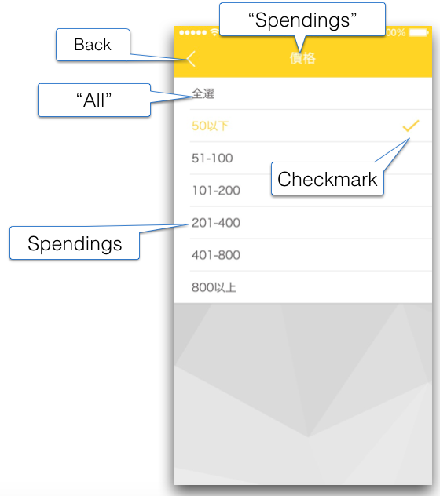~~

**~~Table 10. Filter-Other-Spending Elements~~**

|  |  |  |  |  |
| --- | --- | --- | --- | --- |
| **~~Field Elements~~** | | | | |
| ~~S/N~~ | ~~Labels~~ | ~~Mandatory~~ | ~~Description~~ | ~~Field Specific Validation~~ |
| ~~1~~ | ~~Spendings~~ | ~~N/A~~ | ~~Static Label.~~ |  |
| **~~Buttons~~** | | | | |
| ~~S/N~~ | ~~Name~~ | ~~Description~~ | | |
| ~~1~~ | ~~Back~~ | * ~~Go to S2 Hot-Search-List Page~~ | | |
| ~~2~~ | ~~All~~ | * ~~Checkmark options~~ * ~~If “All” is checked, uncheck other checkmarks~~ * ~~If “All” is unchecked, then no Spendings are selected too~~ | | |
| ~~3~~ | ~~Spending~~ | * ~~Checkmark options~~ * ~~Click to select~~ * ~~If checked, uncheck “All”~~ * ~~Supports multiple check~~ | | |

**~~Important Notes:~~**

1. ~~Change the arrow (cell’s indicator) to checkmark~~

# **S5 – Search > More Dish Type**

This page displays the list of Dishes to select for the filter. Multi-selection is enabled here.

**Figure 11. Filter-Other-Dish Page**

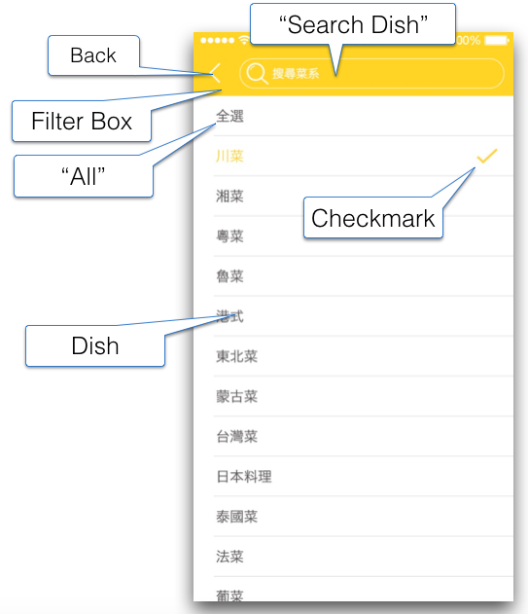

**Done**

Done “Button”

**Table 11. Filter-Other-Dish Elements**

|  |  |  |
| --- | --- | --- |
| **Field Elements** | | |
| S/N | Labels | Description |
| 1 | Search Dish | * TextBox, support Chinese * Filter the bottom list ‘s dish names which contain the inputted text * If empty text, cancel filtering |
| **Buttons** | | |
| S/N | Name | Description |
| 1 | Back | Tap to Return S2 - Hot-Search-List without saving. |
| 2 | Dish Type | * Checkmark options * Supports single check only * Click to select |
| 3 | Done | Tap to Save the selections and Return S2 - Hot-Search-List. |

**Important Notes:**

1. Change the arrow (cell’s indicator) to checkmark
2. List of options is in Samplerestaurantdata.xls > Dish

# **~~S6 – Search Result > Food & Hashtag~~**

This Page is not necessary. Refer S2 – Hot Search.

~~This page displays the results after Searched with the options in S2 Hot-Search-List Page. The layout of this page is beginning from top-left and end at bottom-right.~~

**~~Figure 12. Search-Food/Hashtag Page~~**

~~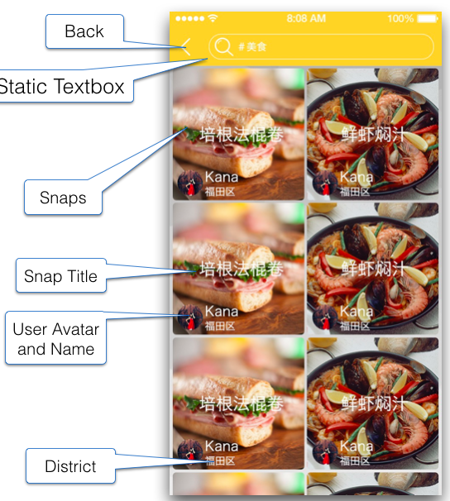~~

**~~Table 12. Search-Food/Hashtag Elements~~**

|  |  |  |  |  |
| --- | --- | --- | --- | --- |
| **~~Field Elements~~** | | | | |
| ~~S/N~~ | ~~Labels~~ | ~~Mandatory~~ | ~~Description~~ | ~~Field Specific Validation~~ |
| ~~1~~ | ~~Search box~~ | ~~N/A~~ | * ~~Read-only TextBox~~ * ~~Display all the Search keywords inputted in S2 Hot-Search-List Page~~ * ~~Keywords are those only been inputted in the Search Box. Not include those in the Other Filter Options~~ |  |
| ~~2~~ | ~~Snap Title~~ | ~~N/A~~ | ~~Static Label.~~  ~~Displays the Snap Title (Food Name) of the Snap~~ | ~~N/A~~ |
| ~~3~~ | ~~User Avatar and Name~~ | ~~N/A~~ | ~~Display the author of the Snap~~ | ~~N/A~~ |
| ~~4~~ | ~~District~~ | ~~N/A~~ | ~~Static Label.~~  ~~Displays the District Name of the Restaurant in Snap~~ | ~~N/A~~ |
| **~~Buttons~~** | | | | |
| ~~S/N~~ | ~~Name~~ | ~~Description~~ | | |
| ~~1~~ | ~~Back~~ | * ~~Go to S2 Hot-Search-List Page with cleared selected options~~ | | |
| ~~2~~ | ~~Snap~~ | * ~~Go to S10 Snap-Details~~ * ~~The whole photo (square) is a button, include the User Avatar~~ | | |
| ~~3~~ | ~~Like~~ | * ~~Toggle Like on this Snap~~ | | |

**~~Important Notes:~~**

1. ~~Snaps are ordered by newer to older posted time~~
2. ~~Display empty results if appropriate~~
3. ~~Implement pagination by detecting that the scroll almost reaches the bottom of the screen so it would retrieve again the next list of the result.~~

# **S7 – Search Result > User**

This page displays the results by searching with prefix @ (@username) in S2 - Search Page, when user specified the username he wanted to search. The search results displays the LAST 3 Snap posts done by the corresponding user. If the user posted no Snap posts, then it displays none.

**S7 - Search-Result-User screenshot**

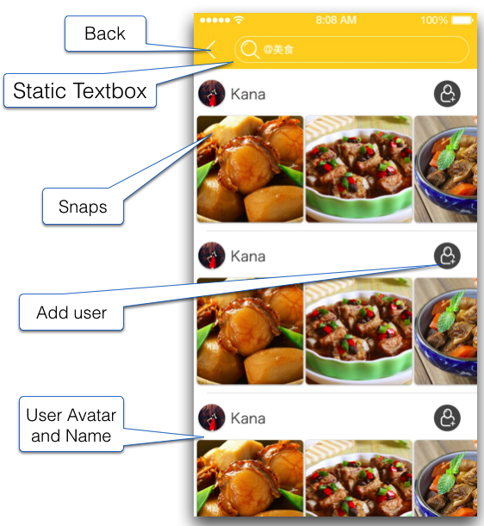

“Like” button

**Table 13.Search-User Page Elements**

|  |  |  |
| --- | --- | --- |
| **Label** | | |
| S/N | Name | Description |
| 1 | {Keyword}  (Search box) | * Read-only like page title without search box UI. * Display only all the Search keywords inputted in S2 Hot-Search-List Page * Keywords are those only been inputted in the Search Box. Not include those in the Other Filter Options. |
| **Buttons** | | |
| S/N | Name | Description |
| 1 | Back  (Icon button) | Tap to Return S2 Hot-Search-List Page and reset all the filters. |
| 2 | Snap | Tap to Go to S10 Snap-Details   * The whole photo (square) is a button. ~~include the User Avatar~~ |
| 3 | ~~Add~~ Follow User | **[Registered user]**   * If logged on, current user Follow this user and stay on this page to display the Follow results   **[Guest user]**  Tap and Display pop-up message.   * Tap “Cancel” to dismiss pop-up and remain. * Tap “Login” to Go to A1 – Starting Page. |
| 4 | User Avatar + Username | Tap to Go to P1B Profile-Followings-Others for the selected user |
| 5 | Like  (Icon button) | **[Registered user]**  Tap “Like” and highlight the icon, also update the count accordingly but not shown here.  Tap “Unlike” and unhighlight the icon, also update the count accordingly but not shown here  **[Guest user]**  Tap “Like” and Display pop-up message.   * Tap “Cancel” to dismiss pop-up and remain. * Tap “Login” to Go to A1 – Starting Page. |

**Important Notes:**

1. Snaps are ordered by newer to older posted time
2. Display empty results if appropriate
3. The layout of this page is flow from top-left to bottom-right. Pagination may be required.
4. Implement pagination by detecting that the scroll almost reaches the bottom of the screen so it would retrieve again the next list of the result.
5. Each user entry result will also need to display the LAST 3 snap posts done by the user below its name just like the screenshot. If user don’t have any snaps yet, then its empty Snaps.
6. If no user found, show background message

# **S10 – Snap Details**

This page displays the information about the Snap’s food, food photos and the restaurant. At the section below, Snaps of related hashtags are shown. The hashtags are added by user and also on the backend system there is another hashtag list managed by Admin, so the Admin controls how to relate between different Snaps.

**Figure 26. Snap-Details Page**

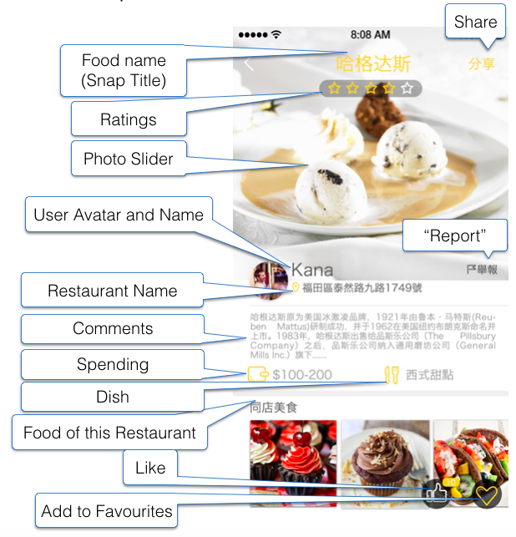

**Table 26. Snap-Details Page Elements**

|  |  |  |
| --- | --- | --- |
| **Label** | | |
| S/N | Section | Description |
| 1 | Food name | Display the Snap Title as provided by user in the S12 Snap-Post Page |
| 2 | Ratings | Display the Ratings as provided by user in the S12 Snap-Post Page |
| 3 | Photo Slider | Display the photos of the food as provided by user in the S12 Snap-Post Page. By default the cover photo displays first |
| 4 | User Avatar | Display the current avatar of user posted this Snap |
| 5 | User Name | Display the Display Name of the user posted this Snap |
| 6 | Restaurant Name | Display Restaurant Name provided by user in the S12 – New Post. It has to be bigger and just smaller then username a bit. |
| 7 | Comments | Display the Comments provided by user in the S12 – New Post  Show full comment. Remove “Expand/Collapse” function. |
| 8 | Hashtags | Not shown in App but Backend server. |
| 9 | Spending | Display the Spending provided by user in the S12 Snap-Post Page. Display below Hashtags field. |
| 10 | Dish Type | Display the Dish name provided by user in the S12 Snap-Post Page. Display below Hashtag field and right to Dish field. Keep it empty if user doesn’t provide in S12. |
| 11 | Menu  {S10_LABEL_01} | Static Label. This is a caption for the section at the bottom when scroll to bottom of this page |
| **Buttons** | | |
| S/N | Name | Description |
| 1 | Restaurant Name | Tap to Go to S11 - Restaurant-Details. |
| 2 | Like  (Floating, Toggle Button) | * Tap to Like (Add count) / Unlike (Remove count) * Store this information in backend server. |
| 3 | Favorites  (Floating, Toggle Button) | * Tap to Add/ Remove this Snap to/from my “Favorites” |
| 4 | Share  (Button) | Tap to Go to S10A – Share Dialog   * Use “Share” icon as same as S1 |
| 5 | User Avatar | Tap to Go to P1B - Other User Profile / P0 – Profile. |
| 6 | Related Snaps | * Displayed at the bottom of this page * When a snap is tapped, go to S10 – Snap Details to show the Snap details |
| 7 | Report | Tap to Go to P6 – Report Page   * This option is only available for snap from other users. |
| 8 | Delete | Tap to Open pop-up message   * Provide option to delete the post. * This option is only available for snap from the own user |

**~~Important Notes:~~**

1. ~~May expand the contents of Comments section. Cannot collapse once expanded.~~

# **S10A - Share Dialog**

This page displays a generic reusable menu to allow Share to different social media platforms. If users haven’t installed the corresponding app, the icon would not display.

**S10A – Share Dialog**

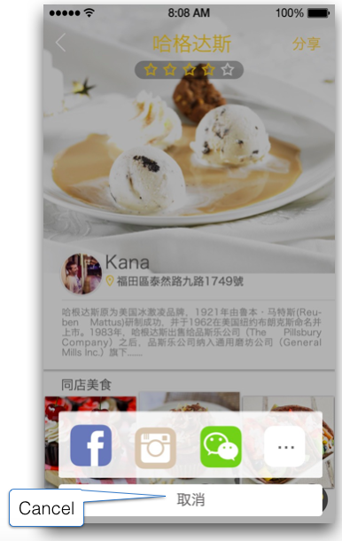

**Share Dialog Elements**

|  |  |  |
| --- | --- | --- |
| **Button** | | |
| S/N | Name | Description |
| 1 | Cancel | Tap to Dismiss the dialog |
| 2 | App Icons | Tap to Open the App with drafted post/passage.  If the App is not installed yet, direct the user to the download page of App Store/ Google Play |

**Figure 30b. Snap-Details-Share Example Page**

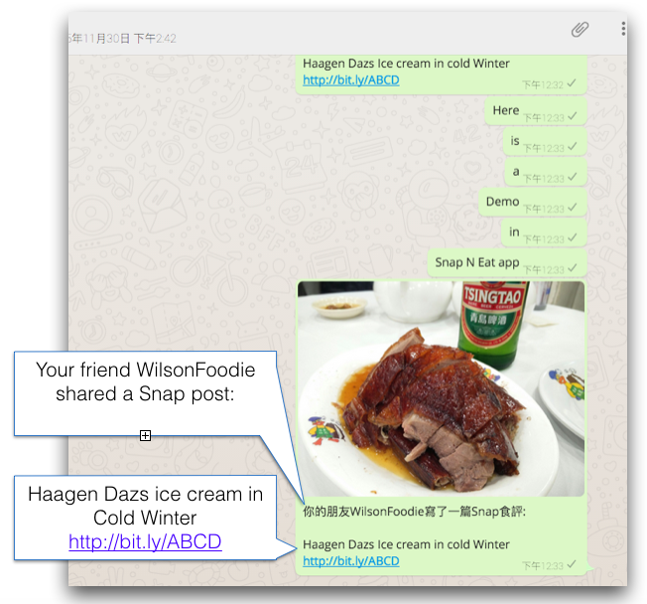

**Table 30b. Snap-Details-Share Example Elements**

|  |  |  |
| --- | --- | --- |
| **Field Elements** | | |
| S/N | Element | Description |
| 1 | Share Post by message | Localization needed.  **Message Template**  Food Snap + {S10A_MESSAGE_01} + {Snap Title} + {App Link}  Click the Open App Link:   * If Snap n Eat App installed, open the related page (S10 – Snap Details) in App. Otherwise, redirect to App Store download page. |
| 2 | Share Post by Public Post | Post it on user’s social account like Facebook, Twitter etc.  **Post Template**  Food Snap + {S10A_MESSAGE_02} + {Snap Title}  Click to Open the page:   * If open in mobile device with App installed, open the related page (S10 – Snap Details) in App. Otherwise, redirect to App Store download page. * If open in PC, direct to Snap n Eat Facebook page. |

**Important Notes:**

1. Supports the following social-media (in priority):
   1. Facebook
   2. Instagram
   3. Wechat
   4. Whatsapp
   5. Line
   6. Twitter
   7. Others (Intent-based) - available in Android only.
2. Pre-set the Apps icon in box, which are able to share the post from Snap n Eat. If the Apps are not installed yet, direct the user to App Store. Checking if app is installed is supported in Facebook, Instagram and Wechat. If they are not installed, redirect the user to App Store/Play Store.
3. The actual app link is base on the actual server URL. We don’t do bit.ly integration here. SERVER must generate the link according to conditions above, and the link must be able to direct users to indicated pages.

# **S10B – Notification (device home screen)**

The shows the Notification design. On the App icon on the device apps Home Screen, the badges should display badge number indicates the number of notifications received.

**Figure 25. Notification**

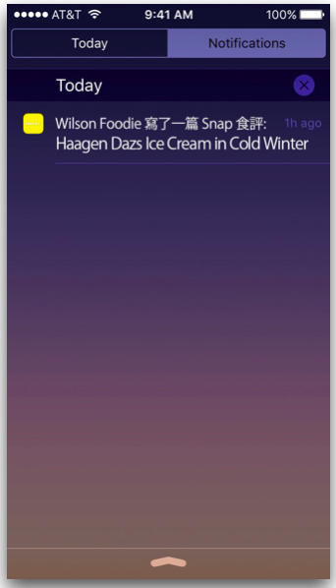

**Table 25. Notification Elements**

|  |  |  |  |  |
| --- | --- | --- | --- | --- |
| **Field Elements** | | | | |
| S/N | Labels | Mandatory | Description | Field Specific Validation |
| 1 | Notification | - | | |
| ~~2~~ | ~~Haagen Dazs Ice cream in Cold Winter~~ | ~~Show the title of the latest Snap.~~  ~~This is the 2nd line of the message~~ | | |
| 3 | Icon | App’s icon small version | | |
| **Action** | | | | |
| S/N | Name | Description | | |
| 1 | Action | Swipe to Open the related page (S10 – Snap Info). ~~Go to the current user’s profile following P1 Profile-Followings Page.~~ Then Dismiss this notification | | |

# **S11 – Restaurant Details**

This page displays the restaurant information and provides navigation to user.

**Figure 27. Restaurant-Details Page**

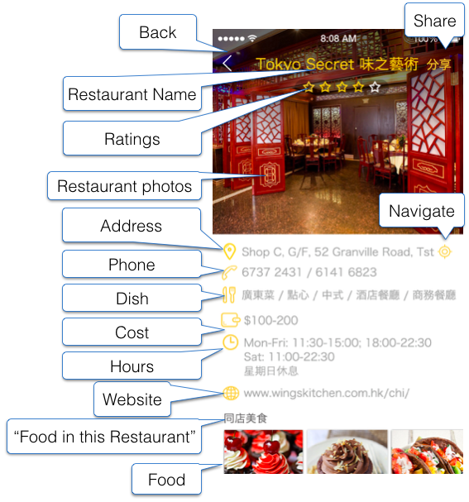

**Table 27. Restaurant-Details Page Elements**

|  |  |  |
| --- | --- | --- |
| **Field Elements** | | |
| S/N | Labels | Description |
| 1 | Restaurant Name | Display the Name of the Restaurant here corresponding to app language. Data from CMS. |
| 2 | Ratings | Graphic representations of Ratings. |
| 3 | Restaurant Photos | * Display Photos of the Restaurant, in this Photo slider * Max 3 photos * Admin provided these Photos in Admin CMS   If restaurant photo is unavailable or missing, display the placeholder image |
| 4 | Address | * Displays the address of the restaurant in the restaurant list maintained in CMS corresponding to each app language |
| 5 | Phone | * This displays the text of Phone numbers input by Admin via CMS |
| 6 | Dish | * This displays the text of Dishes input by Admin via CMS * Dishes names are separated by a slash / , Dish name is localized |
| 7 | Cost | This displays the Cost input by Admin via CMS |
| 8 | Opening Hours | This displays the opening hours input by Admin via CMS corresponding to each app language |
| 9 | Website | * Display Website of the Restaurant corresponding to each app language. Data from CMS. |
| 10 | Menu | * Displays 6 food snaps below this caption with the snap’s cover photos |
| **Buttons** | | |
| S/N | Name | Description |
| 1 | Back | Tap to Go to S10 - Snap-Details |
| 2 | Navigate | Tap to Go to G – GPS Location. |
| 3 | Share | Tap to Go to S – Share Dialog. |
| 4 | Food | Tap to Go to S10 Snap-Details with the selected food. |

**Important Notes:**

1. Restaurant Description may have formatting, e.g. HTML  
   to display opening hours, website link, phone number

# **S12 - New Post**

This page displays a form for registered user to add new post. The detail and the snap are given here. Supports Stop-words.

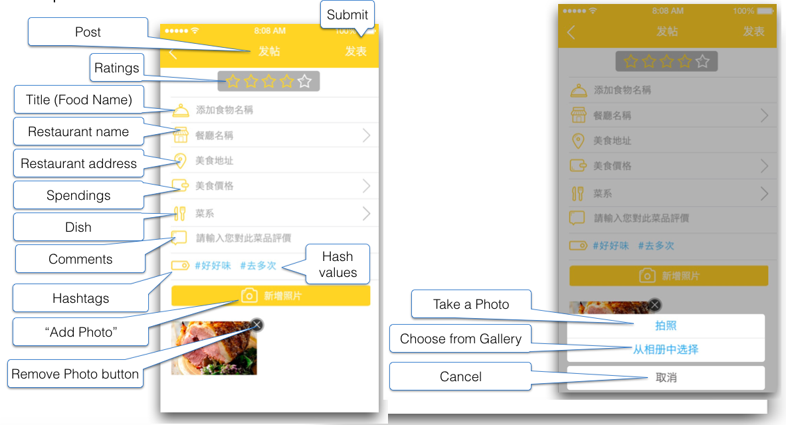

Able to be this page from:

* S1 – Home Page
* P0 – Profile

|  |  |  |
| --- | --- | --- |
| **Label** | | |
| S/N | Name | Description |
| 1 | New Post | Page Title |

|  |  |  |  |
| --- | --- | --- | --- |
| **Input Elements** | | | |
| S/N | Name | Element | Description |
| 1 | Rating | Rating Bar  (Mandatory) | Tap to select rating between 1 to 5 star(s).  **If leave this blank and submit the form:**   1. Display pop-up message  * Tap “OK” to dismiss pop-up. |
| 2 | Food Name | Text Field  (Mandatory) | Tap to Dismiss Hint Text and start input.   * Hint Text   Char space limits:   * Max 40 char space. * Each Chinese char occupies 3 char spaces. * Each Alphanumeric occupies 1 char space.   **If leave this blank and submit the form:**   * Display pop-up message * Tap “OK” to dismiss pop-up. |
| 3 | Restaurant Name | Textbox Button  (Mandatory) | Tap to Go to S13A – Restaurant List.   * Replace “Field Name” with Restaurant Name selected/ input in S13A. * Field Name   **If leave this blank and submit the form:**   1. Display pop-up message.  * Tap “OK” to dismiss pop-up. |
| 4 | Restaurant Address | Text Field  (Optional) | **If existing restaurant selected in database:**  Auto-fill the address.  **If new restaurant added:**  Becomes Text Field and allow user’s input.  Char space limits:   * Max 100 char spaces. * Each Chinese character = 3 char spaces * Each Alphanumeric, symbol, space & punctuation = 1 char space |
| 5 | Spending | Slide Bar  (Mandatory) | Slide bar with 2 buttons same as S2 – Hot Search.  **If leave this blank and submit the form:**   1. Display pop-up message  * Tap “OK” to dismiss pop-up. |
| 6 | Dish Type | Textbox Button  (Optional) | Tap to Go to S5 – More Dish Type. |
| 7 | Comment | Text Field  (Optional) | Optional input.  Char space limits:   * Max 100 char spaces. * Each Chinese character = 3 char spaces. * Each Alphanumeric, symbol, space & punctuation = 1 char space |
| 8 | Hashtag | Text Field  (Optional) | Optional to add Hashtag for the food. Input each Hashtag followed by a space to delimit the Hashtag value.  Char space limits:   * Max 255 char spaces. * Each Chinese character = 3 char spaces. * Each Alphanumeric, symbol, space & punctuation = 1 char space |
| 9 | Add Photo | Button  (Mandatory) | Tap to Open C – Camera Dialog.   * Allow 1 to 5 photo(s). * All photos should be uploaded to server in full resolution. * Thumbnail required for each snap. * Button becomes disabled after 5 photos are selected.   **If leave this blank and submit the form:**   1. Display pop-up message  * Tap “OK” to dismiss pop-up. |
| 10 | Submit | Text Button | Tap to Validate if all sections are valid:   1. If any section not valid, display error message. 2. If all sections are valid after checking within App, submit to server. 3. Loading animation required.   **If success**   1. Display pop-up message and ask if the user going to add more post with this restaurant. Tap “YES” to go to S12 and auto-fill the sections. Tap “NO” to go S10 – Snap Detail with new post.   **If failure**   1. Display pop-up message 2. Tap “OK” to dismiss pop-up and remain.   **[NOTE]**  The new post starts with 1x “Like” automatically. (By user who uploaded it) |
| 11 | Back | Icon Button | **If user did no input in New Post**   1. Tap to Return previous page (S1 or P0)   **If user did input in New Post**   1. Tap to Open pop-up message.  * Tap “Cancel” to dismiss pop-up and remain. * Tap “OK” to discard and return previous page (S1 or P0) |
| 12 | Remove Photo (Top-right corner of the snap) | Button | Tap to remove the snap from upload list. |

**[NOTE]**

1. Save all input details and retrieve for next new post, until the user quit the app.
2. New Post is only visible to uploaded user once it is uploaded. Post will only be opened to all users after Admin approve it via CMS.

# **S12A - New Post > Add Photo**

Refer “C – Camera Dialog”.

# **S13A – Restaurant List**

This page displays a list of restaurant name with address for user to choose. This list comes from a master list managed by admin in CMS. If the user searches for a particular restaurant name but it doesn’t exist, show the screen in the right side asking the user if he wants to add the restaurant. The restaurant name + the user’s current location will be used in the restaurant info of the snap. We don’t verify if the location is in HK or not.

**Figure 21. Snap-Post-Restaurant-List Page**

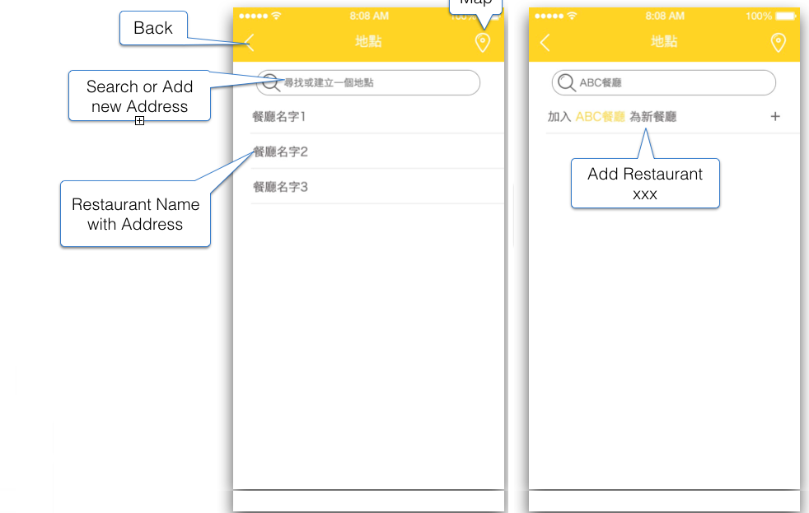

**Table 21. Snap-Post-Restaurant-List Page Elements**

|  |  |  |
| --- | --- | --- |
| **Label** | | |
| S/N | Name | Description |
| 1 | Restaurant | Page Title |
| 2 | Search or Add new Restaurant | Text Field. |
| 3 | Address | Static label, bundled with restaurant name. |

|  |  |  |
| --- | --- | --- |
| **Buttons** | | |
| S/N | Name | Description |
| 1 | Back | Tap to Return to S12 – New Post. |
| 2 | Restaurant | Tap to Select and Return S12 – New Post, and set the selected restaurant |
| 3 | Map | * Get address from a Map screen * Select a nearby restaurant on G2 Map page * The Maps display nearby restaurants in a radius of 2KM to the user |
| 4 | Add Restaurant [Restaurant-Name]  Chinese:  加入[Restaurant-Name]為新餐廳 | * Click and go to S12 Snap-Post Page and set this new restaurant * If the user presses the add button, the restaurant + the user's current location will be added in the server to a pending restaurant list. And also will be used in the S12 screen. * For the list of restaurants list (master list), until admin adds the pending restaurant to master list then will display in this master list. |

**Important Notes:**

1. The restaurants choices are from a list managed by Admin in CMS. This changes randomly time to time so please refresh this list at the start of this page.
2. If the user presses the add button, the restaurant + the user's current location will be added in the server to a pending restaurant list.
3. And also will be used in the S12 Snap-Post page.
4. For the list of restaurants list (master list), until admin adds the pending restaurant to master list then will display in this master list.
5. The restaurants must be listed in order:

Chinese version: 少筆劃 to多筆劃 > A to Z.

English version: A to Z > 中文少筆劃 to多筆劃.

1. Display the result according to the sort by the nearest location.

# **P0 – My Profile**

It is the upper section of the user’s profile page.

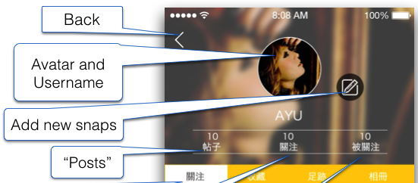

Menu

My Followings

My Followers

Gallery

Footprint

Favorite

Feeds

**P0 - Profile Page Elements**

|  |  |  |
| --- | --- | --- |
| **Label** | | |
| S/N | Name | Description |
| 1 | Username | Username |

|  |  |  |
| --- | --- | --- |
| **Button** | | |
| S/N | Name | Description |
| 1 | Posts | Tap to Go to P5C – My Posts. |
| 2 | Following | Tap to Go to P5A – My Followings. |
| 3 | Followers | Tap to Go to P5B – My Follower. |
| 4 | Menu | Tap to Open M – Side Menu |
| 5 | New Post | Tap to Go to S12 – New Post. |
| 6 | User Avatar | Tap to Open P1A – My Profile > Avatar Change. |
| 7 | Feeds | Tap to Switch the lower section to P1. |
| 8 | Favorite | Tap to Switch the lower section to P2. |
| 9 | Footprint | Tap to Switch the lower section to P3. |
| 10 | Gallery | Tap to Switch the lower section to P4. |

# **P1A – My Profile > Avatar Change**

Refer to “C – Camera Dialog”.

# **P1 – My Profile > Feeds**

The lower section of profile that displays the recent Snaps feeds from the following users.

**Figure 14. Profile-Followings Page**

Page Title, highlighted when selected

Snap

Food Name

Avatar & Username

District

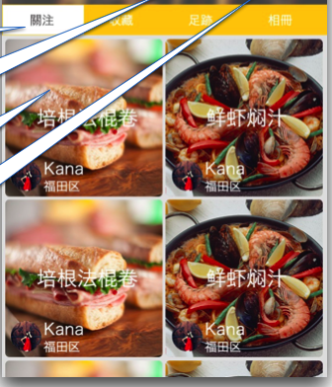

|  |  |  |
| --- | --- | --- |
| **Buttons** | | |
| S/N | Name | Description |
| 1 | Snap | Tap to Go to S10 – Snap Details.  Display 3 snaps per row instead of current 2.  **If no internet connection or no snap found:**   * Display message on background. |
| ~~2~~ | ~~Food Name~~ | Snap Title not shown. |
| 3 | Avatar +  Username | The user who uploaded this snap.  Tap to Go to P1B – Other User Profile. |

|  |  |  |
| --- | --- | --- |
| **Label** | | |
| S/N | Name | Description |
| ~~1~~ | ~~District~~ | Not shown. |
| 1 | Feeds | Page Title. Highlighted when selected. |

# **P2 – My Profile > Favorites**

This lower section of profile displays the Snaps that the user added to Favourites.

**Figure 15. Profile-Favourites Page**

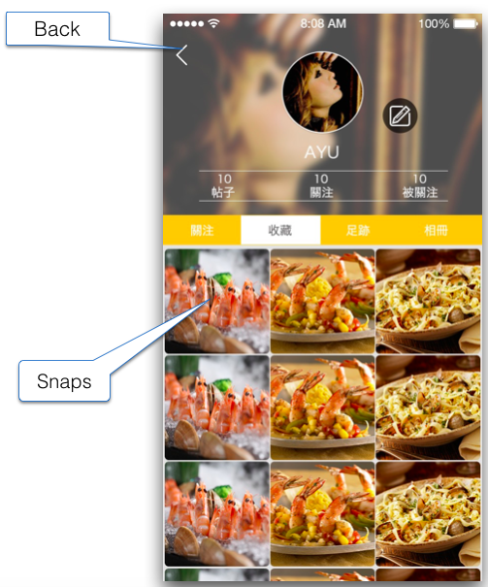

**Table 15. Profile-Favourites Page Elements**

|  |  |  |
| --- | --- | --- |
| **Buttons** | | |
| S/N | Name | Description |
| 1 | Snap | Tap to Go to S10 – Snap Detail.  Display 3 snaps per row.  **If no internet connection or no snap found:**   * Display message on background. |
| **Label** | | |
| 1 | Favorite | Page Title. Highlighted when selected. |

**[Important Notes for P1 & P2]**

1. Snaps are ordered by the newest to the older of the date added
2. The layout of this page is flow from top-left to bottom-right. Pagination may be required.
3. Implement pagination by detecting that the scroll almost reaches the bottom of the screen so it would retrieve again the next list of the result.

# **P3 – My Profile > Footprints**

This lower section of profile displays the Snaps that the user posted. The Snaps are organized into groups of Districts so user can recapture what food in nearby districts in the future. Snaps are grouped by Districts ordered by nearest to distance.

**Figure 16. Profile-Footprints Page**

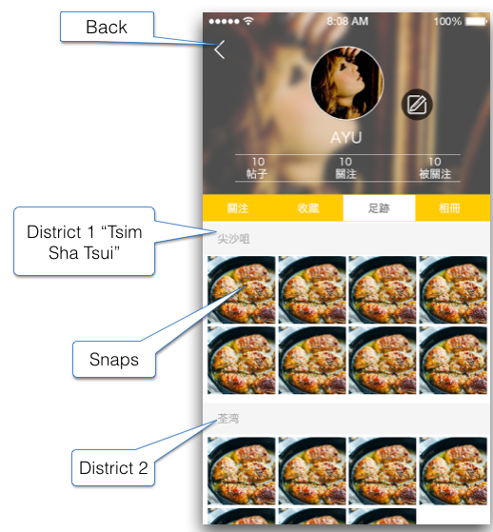

**Table 16. Profile-Footprints Page Elements**

|  |  |  |
| --- | --- | --- |
| **Label** | | |
| S/N | Name | Description |
| 1 | Footprints | Page Title. Highlighted when selected. |
| 2 | District Name | Sorting the distance   * For each district, at most display 4 snaps. |

|  |  |  |
| --- | --- | --- |
| **Buttons** | | |
| S/N | Name | Description |
| 2 | Snap | Tap to Go to S10 – Snap Detail.   * Display 4 snaps per row for each district.   **If no internet connection or no snap found:**   * Display message on background. |

# **P4 – My Profile > Gallery**

This lower section of profile displays the Snaps that the user posted.

**Figure 17. Profile-Gallery Page**

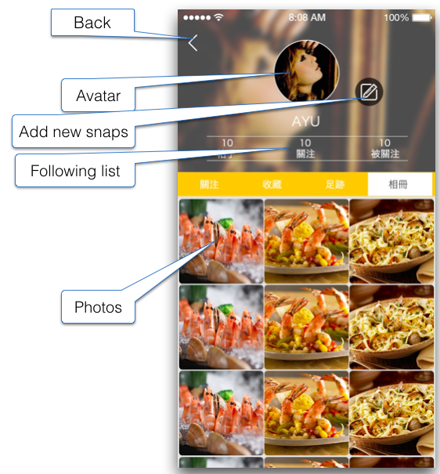

**Table 17. Profile-Gallery Page Elements**

|  |  |  |
| --- | --- | --- |
| **Label** | | |
| S/N | Labels | Description |
| 1 | Gallery | Page Title. Highlighted when selected. |

|  |  |  |
| --- | --- | --- |
| **Buttons** | | |
| S/N | Name | Description |
| 2 | Snap | Tap to Go to S10 – Snap Detail.   * Display 3 snaps per row.   **If no internet connection or no snap found:**   * Display message on background. |

**[Important Notes for P3 & P4]**

1. The layout of this page is flow from top-left to bottom-right. Pagination may be required
2. Implement pagination by detecting that the scroll almost reaches the bottom of the screen so it would retrieve again the next list of the result.
3. Difference between P4 - Gallery and P3 - Footprints: Snaps are also the user posted. But in Footprints, Snaps are grouped by Districts ordered by nearest to distant. In Gallery, Snaps are ordered by recent to older.

# **P5A – Following**

This page displays a list of followings user.

**Figure 18. Followings-List Page**

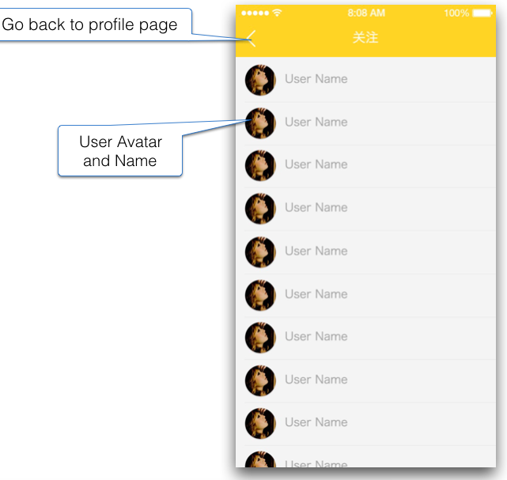

Unfollow/ Follow toggle button

|  |  |  |
| --- | --- | --- |
| **Label** | | |
| S/N | Labels | Description |
| 1 | Following  {P5A_PAGE TITLE} | Page Title |
| **Buttons** | | |
| S/N | Name | Description |
| 1 | Back | Tap to Return P0 – My Profile. |
| 2 | Avatar & Username | Tap to Go to P1B - Other User Profile |
| 3 | Follow/ Unfollow  (Toggle Button) | Tap to Toggle Follow/ Unfollow the user.   * Highlighted when following and Unhighlighted when not following (refer P1B – Other Profile) * The unfollowed user is just removed from this list after re-enter this page. |

**[NOTE]**

1. If the user isn’t following any user, show background message.

# **P5B – My Followers**

This page displays a list of Followers. The similar layout is used as P5A - Followings List.

**Figure 18. Followings-List Page**



Unfollow/ Follow toggle button

|  |  |  |
| --- | --- | --- |
| **Label** | | |
| S/N | Labels | Description |
| 1 | Followers  {P5B_PAGE TITLE} | Page Title |
| **Buttons** | | |
| S/N | Name | Description |
| 1 | Back | Tap to Return P0 – Profile. |
| 2 | Username | Tap to Go to P1B - Other User Profile |
| 3 | Follow/ Unfollow  (Toggle Button) | Tap to Toggle Follow/ Unfollow the user.   * Highlighted when following and Unhighlighted when not following (refer P1B – Other Profile) * The unfollowed user is just removed from this list after re-enter this page. |

**[NOTE]**

1. If the user isn’t following any user, show background message.

# **P5C – My Posts**

This page displays the list of user’s post history. It consists of rectangle button(s) bundle with a few elements listed below

**Post History screenshot**

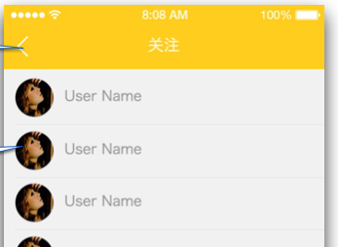

Cover Photo of Food Snap

Food Name/ Snap Title

Back

5

5

5

Total snaps of this post

Delete Post

|  |  |  |
| --- | --- | --- |
| **Label** | | |
| S/N | Labels | Description |
| 1 | Post History  {P5C_PAGE TITLE} | Page Title |
| 2 | Number of Snap | The total snaps that the user uploaded in S12 – New Post for this post before. |

|  |  |  |
| --- | --- | --- |
| **Buttons** | | |
| S/N | Name | Description |
| 1 | Back | Tap to Return P0 – Profile. |
| 2 | Snap Title | Elements bundled at the left hand side inside a rectangle button in screenshot shown above.  Tap to Go to S10 – Snap Details |
| 3 | Delete  (Icon button) | Tap to Open pop-up message   * Tap “Yes” to delete the post from user profile (but not in SERVER). * Tap “No” to dismiss and return P5C. |

# **P1B – Other Profile**

This page displays Profile of the other users.

**Figure 22. Profile-Followings-Others Page**

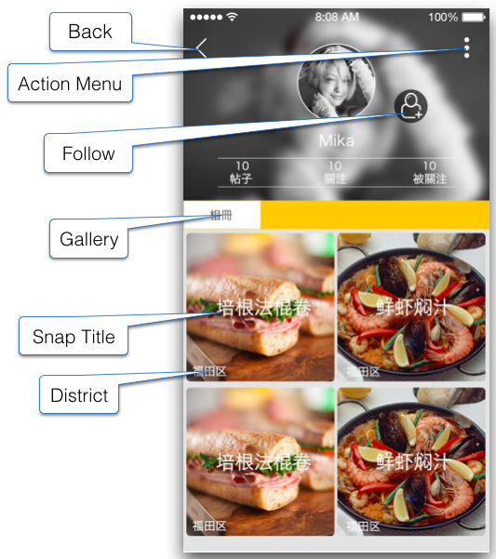

**Table 22. Profile-Followings-Other Page Elements**

|  |  |  |  |  |
| --- | --- | --- | --- | --- |
| **Field Elements** | | | | |
| S/N | Labels | Mandatory | Description | Field Specific Validation |
| 1 | Gallery  Chinese:  相冊 | N/A | Static Label.  TabBar | N/A |
| 2 | Snap Title | N/A | Static Label.  Displays the Snap Title (Food Name) of the Snap | N/A |
| 3 | District | N/A | Static Label.  Displays the District Name of the Restaurant in Snap | N/A |
| **Buttons** | | | | |
| S/N | Name | Description | | |
| 1 | Back | * Go to previous page in Back Stack | | |
| 2 | Action Menu | * Go to P1C Profile-Action-Menu Page | | |
| 3 | Follow | * Follow means subscribe to this user * Once user follows on this other user, it is automatically A receiving notifications about the other user’s new Snaps * On success or fail, show messages and stay on this page * Won’t be available if the user was already been subscribed by the logged on user. | | |

# **~~P1C – Other Profile > Action Dialog~~**

Remove this feature.

~~This page displays menu about actions on currently displayed user.~~

**~~Figure 23. Profile-Action-Menu Page~~**

~~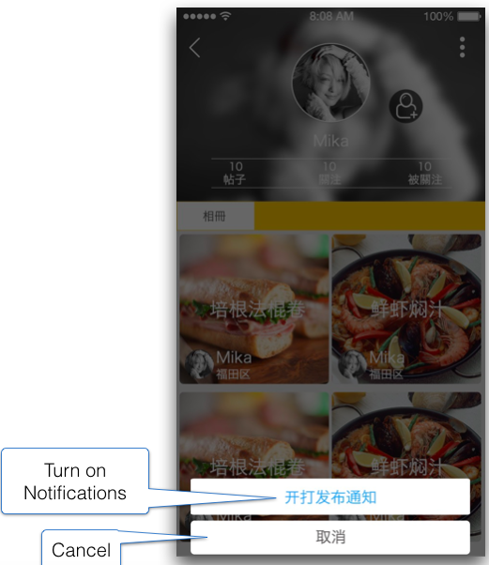~~

**~~Table 23. Profile-Action-Menu Elements~~**

|  |  |  |
| --- | --- | --- |
| **~~Buttons~~** | | |
| ~~S/N~~ | ~~Name~~ | ~~Description~~ |
| ~~1~~ | ~~Report Inappropriate~~ | * ~~Go to P6 Report-Inappropriate Page~~ |
| ~~2~~ | ~~Turn on Notifications~~  ~~Chinese:~~  ~~開啟發佈通知~~ | * ~~Post to server for toggling receive notifications from the displayed user~~ * ~~The button caption should change from “Turn on” to “Turn off” (Chinese: 關閉)~~ * ~~Prompts for results~~ * ~~ONLY AVAILABLE if the user has already followed the user and also enabled turning on the notification for this user.~~ * ~~NOT AVAILABLE if the user is not yet followed.~~ |
| ~~3~~ | ~~Cancel~~ | ~~Tap to Dismiss.~~ |

# **P6 – “Report” page**

This page provides a form for user to submit the reason of reporting inappropriate snap post. This page is directed from S10 – Snap Info.

**Figure 24. Report-Inappropriate Page**

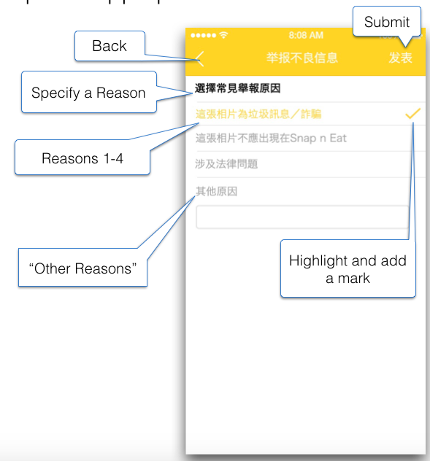

**Table 24. Report-Inappropriate Page Elements**

|  |  |  |
| --- | --- | --- |
| **Label** | | |
| S/N | Labels | Description |
| 1 | Report | Page Title |
| 2 | Reason | Section Name |

|  |  |  |
| --- | --- | --- |
| **Button** | | |
| S/N | Name | Description |
| 1 | Back | Tap to Return S10 – Snap Details. |
| 2 | Send | Tap to Submit form.   1. APP validates if any reason button checked.  * If nothing is selected/checked, display pop-up message. Tap “OK” to dismiss pop-up. * If valid, submit form to SERVER. Meanwhile, apply loading animation.  1. APP waiting for SERVER’s response.  * If failure, display pop-up error message. Tap “Retry” to send again. * If success, SERVER returns APP and display pop-up message. Tap “OK” to dismiss and return to the page, which user enters the reported snap from. |
| 3 | Other Reasons | Tap to Select and Check the textbox, as well as Enable the Text Field for input. |
| 4 | Option 1 | Tap to Select and Check the textbox.  “With inappropriate/ offensive contents” |
| 5 | Option 2 | Tap to Select and Check the textbox.  “Legal Issue” |

And more options will be listed.

|  |  |  |
| --- | --- | --- |
| **Text Field** | | |
| S/N | Item | Description |
| 1 | Other Reason | Char space limits:   * Max 100 char spaces. * Each Chinese character = 3 char spaces. * Each Alphanumeric, symbol, space & punctuation = 1 char space |

**Important Notes:**

1. The list of Reasons are fixed, localization required
2. Upon this form is submitted, admin can view the reported inappropriate Snaps
3. The reported snap becomes temporarily invisible to other users (not the user who uploads), until Admin handles the report in CMS.

# **A6 - Settings**

This page displays various settings for users.

**Figure 31A. Settings (User)**

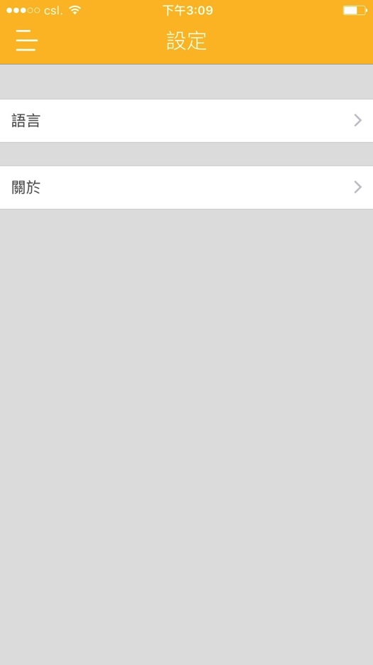

我的帳戶

更改密碼

連結帳戶

登出

語言

關於本程式

推送通知

**Figure 31. Settings (Guest)**



語言

關於本程式

推送通知

**Table 31. Settings**

|  |  |  |  |
| --- | --- | --- | --- |
| **Label** | | | |
| S/N | Name | Description | |
| 1 | Settings | Page Title | |
| **Buttons** | | | |
| S/N | Name | Description | |
| 1 | My Account | Tap to Go to A7 – My Account   * Only available for registered user. | |
| 2 | Connected Social Account | Tap to Go to A8 – Social Account   * Only available for registered user | |
| 3 | Change Password | Tap to Go to A12 – Change Password   * Only available for registered user. | |
| 5 | Language | Tap to Go to A13 – Language. | |
| 6 | Push Notifications | Tap to Go to A15 – Push Notifications | |
| 7 | About | Tap to Go to A10 – About | |
| 8 | Menu (icon) | Tap to Open M - Main Menu | |
| 9 | Logout | Tap to Logout and return to A1 – Starting Page   * Submit to server to logout * Logout should always success on client side * Only available for registered user. | |
| ~~10~~ | ~~Sign Up/ Login~~ | * ~~Go to A3 Login Page~~ * ~~Hidden in Logged in Mode~~ | |
| **Pop-up message** | | | |
| S/N | Condition | | Description |
| 1 | When user tap to delete account. | | Tap to Open first pop-up message.   * Wording refers to latest textlist. * Tap “Cancel” to Dismiss pop-up box * Tap “OK” to Go to double confirmation. |
| 2 | Double confirmation pop-up for deleting account | | Tap to Delete Snap N Eat account   * Wording refers to latest textlist. * Tap “Cancel” to Dismiss pop-up box. * Tap “OK” to submit request to server. * Loading Animation is required before the process completed. * Account deactivated and server responds to app. Then Go to A1. |
| 3 | When user tap to log out the account | | Tap to Open pop-up message   * Wording refers to latest textlist. * Tap “Cancel” to Dismiss pop-up box. * Tap “OK” to logout and return A1. |

# **A7 – Settings > My Account**

This page displays the account information of current user.

**Figure 32. My Account**

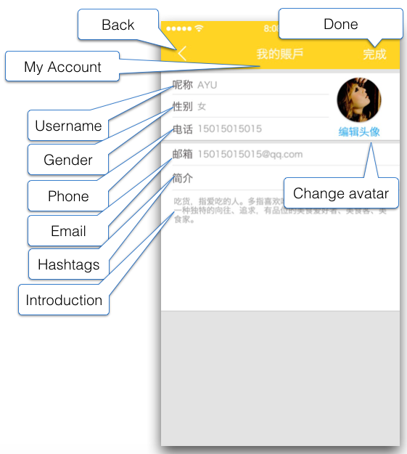

**Table 32. My Account**

|  |  |  |  |
| --- | --- | --- | --- |
| **Label** | | | |
| S/N | Name | Description | |
| 1 | My Account | Page Title | |
| 2 | Username | Text Field Name | |
| 3 | Gender | Field Name | |
| 4 | Phone | Text Field name | |
| 5 | Email | Field Name | |
| ~~6~~ | ~~Hashtags~~ | ~~Text Field Name. Allow users to describe themselves with hashtags.~~ | |
| ~~7~~ | ~~Info~~ | ~~Text Field Name. Allow users to describe themselves with a passage.~~ | |
| **Buttons** | | | |
| S/N | Name | | Description |
| 1 | Back (icon) | | Tap to Return to A6 - Settings |
| 2 | Gender | | Tap to Open Gender Dialog   * “Not Specific” as Default. * Tap any option (Female/ Male/ Not specific) to take immediate effect. * Return to A7. |
| 3 | Avatar Image & Change Avatar | | Tap to Go to A7A – Avatar Change |
| 4 | ~~Done~~  Save | | Tap to Submit update to server.   * Loading animation required while waiting for server’s response. * If success, show notification pop-up on A7. Tap “OK” to Return A6 – Settings * If fail, show notification pop-up. Tap “OK” to remain this page. All new input are kept. |
| **Text Fields** | | | |
| S/N | Name | | Description |
| 1 | Username | | Read-only. It must be the registered email. |
| 2 | Phone | | Tap to Input in text field.   * ~~Mainly HK and mainland phone numbers~~ * Supports numeric only. * Max numbers = 20 |
| 3 | Email | | Read-only. It must be the registered email. |

# **A7A – Settings > My Account > Avatar Change**

Refer “C – Camera Dialog”.

# **A8 – Settings > Social Account**

This page displays the different Social media services that user can connect to.

Currently we only have Facebook to connect to.

**Social Account**

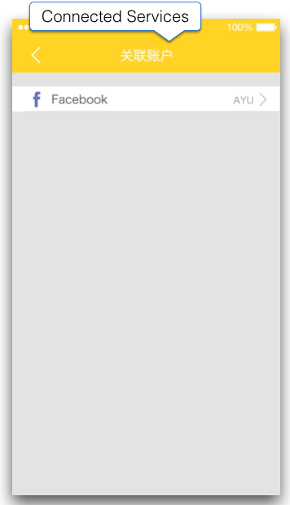

|  |  |  |
| --- | --- | --- |
| **Label** | | |
| S/N | Labels | Description |
| 1 | Connected Social Account | Page Title |
| **Button** | | |
| S/N | Name | Description |
| 1 | Facebook icon, name & User Account Name | **[User registered with social account]**  Tap to Open and Display message pop-up.   * Tap “Cancel” to Dismiss pop-up and remain. * Tap “OK” to log out and Return A1-Starting Page.   ~~Facebook Login is supported.~~  ~~Clicks to launch Facebook Login dialog.~~  ~~Display the connected Facebook user name on the right hand side.~~  ~~Onclick, prompts to ask for disconnect~~ |
| 2 | Other potential Social Account | (See above) |

# **A10 – Settings > About**

This page displays the ~~About informat~~ version number and disclaimer of the App.

**Figure 35. About**

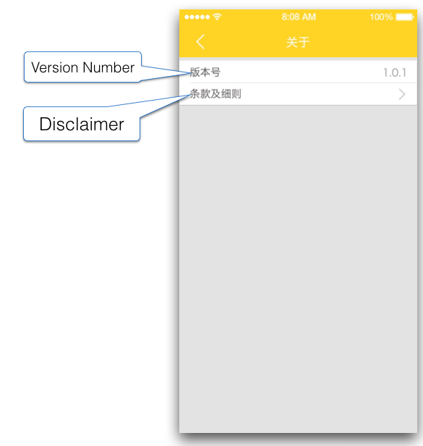

**Table 35. About**

|  |  |  |
| --- | --- | --- |
| **Label** | | |
| S/N | Name | Description |
| 1 | About | Page Title |
| 2 | Version Number | Static Label, read-only |
| **Buttons** | | |
| S/N | Name | Description |
| 1 | Disclaimer | Tap to Go to A11 – Disclaimer |
| 2 | Back (Icon) | Tap to Return A6 - Settings |

# **A11 – Settings > Disclaimer**

This page displays disclaimer.

**Figure 36. Disclaimer**

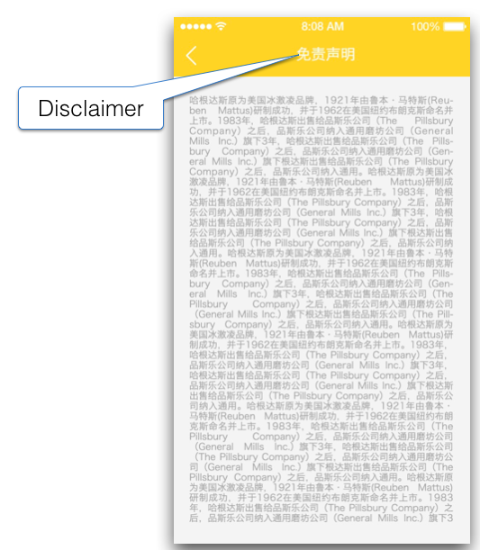

**Table 36. Disclaimer**

|  |  |  |
| --- | --- | --- |
| **Label** | | |
| S/N | Name | Description |
| 1 | Disclaimer | Page Title |
| **Buttons** | | |
| S/N | Name | Description |
| 1 | Back (icon) | Return to A10 - About |

# **A12 – Settings Password Change**

This page displays the form to reset the password of current user.

**Figure 37. Change Password**

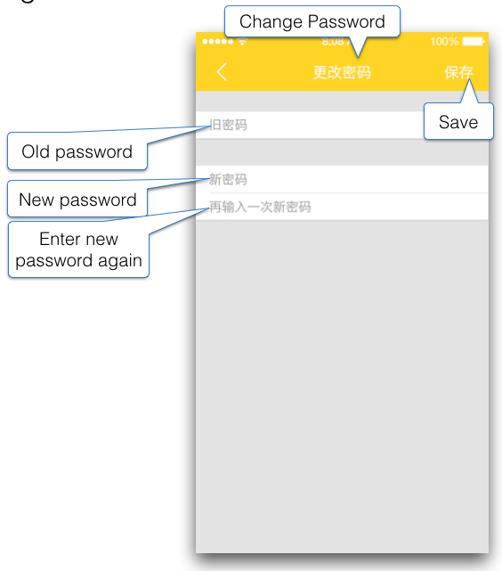

**Table 37. Settings-Change-Password Page Elements**

|  |  |  |  |  |  |  |
| --- | --- | --- | --- | --- | --- | --- |
| **Label** | | | | | | |
| S/N | Labels | Description | | | | |
| 1 | Change Password | Page Title | | | | |
| **Text Field** | | | | | | |
| S/N | Hint Text | | Description | | | Validation |
| 1 | Old Password | | Mandatory | | | Validate if same as current password. If not, show error message. |
| 2 | New Password | | Mandatory | | | Validate if it fit the password requirement. If not, show error message. |
| 3 | Confirm New Password | | Mandatory | | | Validate if same as the New Password field. If not, show error message. |
| **Buttons** | | | | | | |
| S/N | Name | | | Description and Validation | | |
| 1 | Save | | | * Tap to Submit Change Password request to server. * All buttons and text fields become disable during loading. * Loading Animation is required when waiting for server feedback. This process must not be longer than 5 seconds * Display pop-up message accordingly. | | |
| 2 | Back (icon) | | | Return to A6 – Settings | | |
| **Pop-up Message** | | | | | | |
| S/N | Condition | | | | Description | |
| 1 | Old Password not correct. | | | | * Wording refers to latest textlist. * Tap “Ok” to dismiss pop-up. | |
| 2 | Length of Password not meet requirement | | | | * Wording refers to latest textlist. * Tap “Ok” to dismiss pop-up. | |
| 3 | Characters used not meet requirement. | | | | * Wording refers to latest textlist. * Tap “Ok” to dismiss pop-up. | |
| 4 | New Password and Confirm Password differs | | | | * Wording refers to latest textlist. * Tap “Ok” to dismiss pop-up. | |
| 5 | Password update succeeded. | | | | * Wording refers to latest textlist. * Tap “Ok” to dismiss and return A6. | |
| 6 | Password update failed. | | | | * Wording refers to latest textlist. * Tap “Ok” to dismiss pop-up. * Keep all input textfield filled as same as before submit. | |

# **A13 – Settings > Language**

This page displays the form to select and apply the display language for the Snap N Eat app. Upon first launch of the application, the app will check the system language being set in the phone, it will use it to set to the app language. if cannot detect, default to English.

**Figure 38. Language**

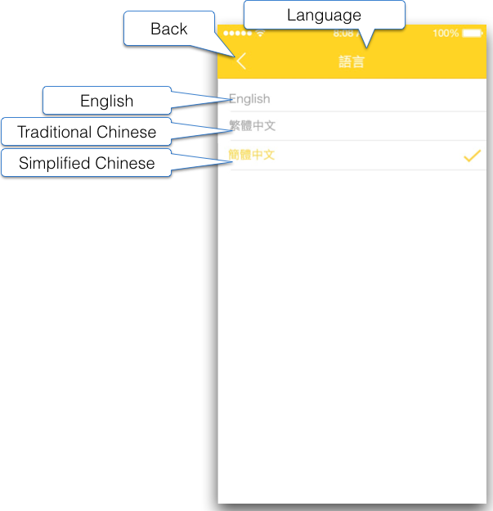

**Table 38. Language**

|  |  |  |
| --- | --- | --- |
| **Label** | | |
| S/N | Labels | Description |
| 1 | Language | Page Title |
| **Buttons** | | |
| S/N | Name | Description |
| 1 | Back | Tap to Return A6 - Settings. |
| 2 | English | * Tap to take immediate effect * Loading Animation applied. |
| 3 | 繁體中文 | * Tap to take immediate effect * Loading Animation applied. |
| 4 | 简体中文 | * Tap to take immediate effect * Loading Animation applied. |

# **A15 – Settings > Push Notifications**

This page displays the options to turn on/off notifications on the Android / iOS system about Snap N Eat App.

**Push Notification Page**

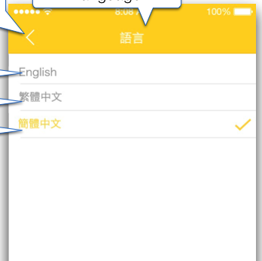

新帖子通知

**推送通知**

|  |  |  |
| --- | --- | --- |
| **Label** | | |
| S/N | Labels | Description |
| 1 | Push Notifications | Page Title |
| **Buttons** | | |
| S/N | Name | Description |
| 1 | Back | Tap to Return to A6 - Settings |
| 2 | New Post  (Switch Button) | Toggle to Turn ON/OFF of receiving notification about following user’s new post.   * Turn ON to send the notification settings to server. * Server save this setting. * Send Notification once user’s following add new post. * Default = ON. |

# **A16 – Settings > Help**

This page shows the option that allows users to view the tutorial page again.

**Help Page**



Home Page

**.幫助**

My Profile

Snap Details

Restaurant Details

|  |  |  |
| --- | --- | --- |
| **Label** | | |
| S/N | Labels | Description |
| 1 | Help | Page Title |
| **Buttons** | | |
| S/N | Name | Description |
| 1 | Tutorial Section (Button) | Tap to Open Tutorial Page. Refer A14 – Tutorial Page |

# **C - Camera Dialog**

This dialog (functions) apply to following section:

- A7A - Settings > My Account > Avatar Change

- P1A - My Profile > Avatar Change

- S12A - New Post > Add Photo

Tap to Open camera dialog.

**A7A – Change Avatar (My Account)**

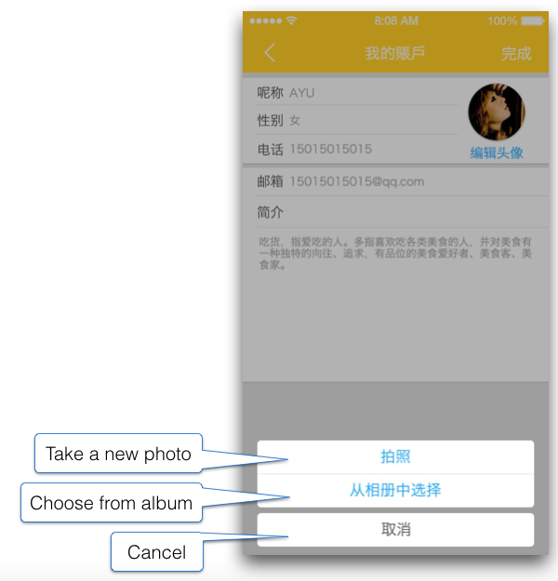

**P1A – Change Avatar (My Profile)**

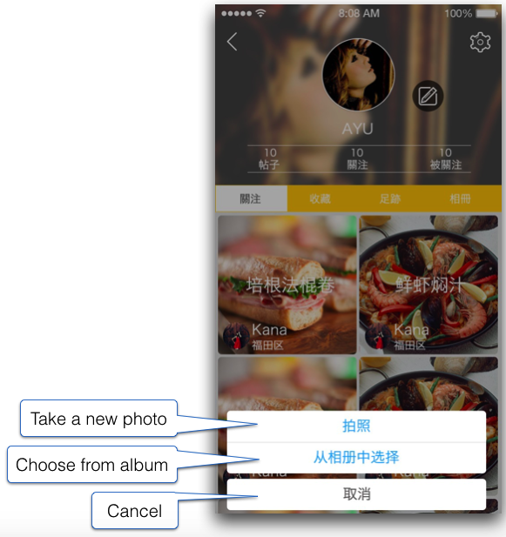

**S12A – Add Photo (New Post)**

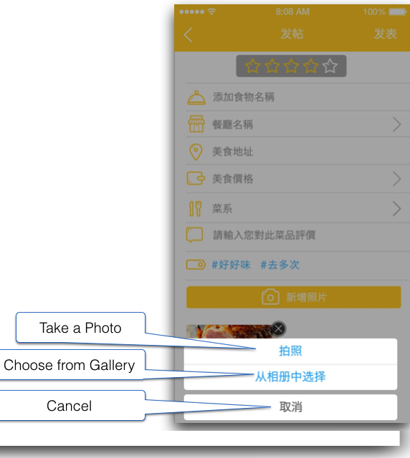

**Camera Dialog**

|  |  |  |
| --- | --- | --- |
| **Buttons** | | |
| S/N | Name | Description |
| 1 | Take Photo | Tap to Launch built-in “Camera”   * Follow common flow - Take, (Retake) & Done.   After user Tap “Done”:   * Center-fill the photo in image view. * Update the avatar & wallpaper in App immediately * Submit update to server. Loading animation applied if necessary.   Return to A7 / P1 / S12 accordingly.  **[Avatar Change in A7A/P1A]**   * Allow 1 photo used only.   **[Add Photo in S12 New Post]**   * Allow up to 5 photos taken and used. |
| 2 | Photo Library | Tap to Open Built-in “Photo Album”.   * Follow common photo selection.   After user press “Select” in Photo Album:   * Center-fill the photo in image view. * Update the avatar & wallpaper in App immediately * Submit the update to server. Loading animation applied if necessary. * The uploaded image stored on server side should be in thumbnail size (150x112), instead of full-sized image from the mobile device.   Return to A7 / P1 / S12 accordingly.  **[Avatar Change in A7A/P1A]**   * Allow 1 photo selected and used only.   **[Add Photo in S12 New Post]**   * Allow up to 5 photos are selected and used. |
| 3 | Cancel | Tap to Dismiss Camera Dialog  Return to the page where the user launch camera dialog. |

**[NOTE]**

1. Support all functions and features provided by built-in camera.

# **T - Tutorial Page**

This is tutorial section that shows at the first time of visiting different sections in App. Each section contains 3-5 screen pages. The user could also view the tutorial page again in A16 – Help.

**Tutorial Pages (Screen for reference)**

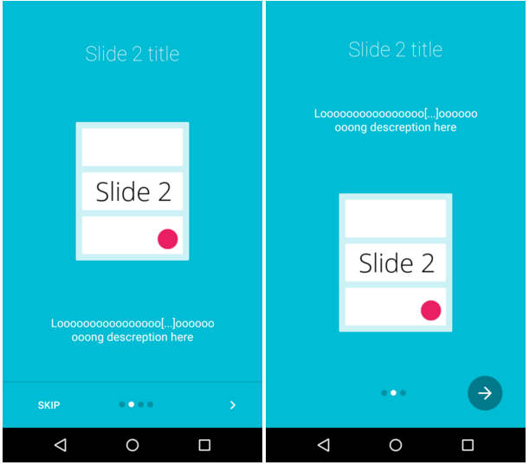

**Table 6A. Tutorial Page Elements**

|  |  |  |
| --- | --- | --- |
| **Field Elements** | | |
| S/N | Labels | Description |
| 1 | Tutorial Page | Each page shows a step of with title and short description. Each section may have 3-5 pages.  Swipe Left to Go next page, or Swipe right to Go previous Page |
| **Buttons** | | |
| S/N | Name | Description |
| 1 | Skip (Done) | Tap to Dismiss tutorial page and Enter the relevant section. If it is the last page of the section. Use “Done” instead of “Skip”. |

**G1 - GPS-Dialog**

Refer “G – GPS Location”.

# **G – GPS Location**

The page show the location of the restaurant directed from S1 – “Home” page or S11 – Restaurant Info. ~~(If provided) and/or other nearby restaurants. This map only shows the list of restaurants around 2KM radius from the user’s current location (centered on screen)~~.

This function must be available with Internet Connection enabled but not GPS location. ~~This page displays the dialog asking for turning on GPS above the map. This is only available in iOS. Also you cannot control the message and the button titles. This only shows once before G2 Map Page in iOS. For Android: (~~[~~https://developers.google.com/android/reference/com/google/android/gms/location/LocationSettingsRequest.Builder~~](https://developers.google.com/android/reference/com/google/android/gms/location/LocationSettingsRequest.Builder)~~). For iOS: (~~[~~http://www.howtogeek.com/177711/ios-has-app-permissions-too-and-theyre-arguably-better-than-androids/~~](http://www.howtogeek.com/177711/ios-has-app-permissions-too-and-theyre-arguably-better-than-androids/)~~)~~

**Figure 28. GPS-Dialog Page**

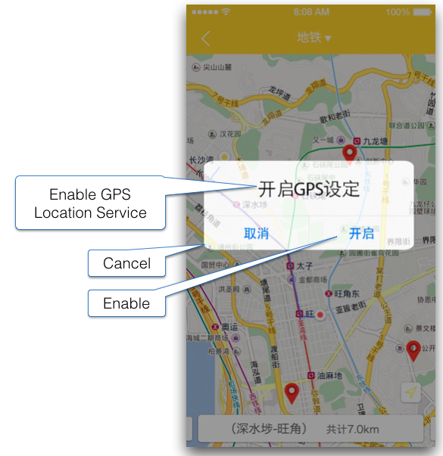

**Figure 29. Map Page**

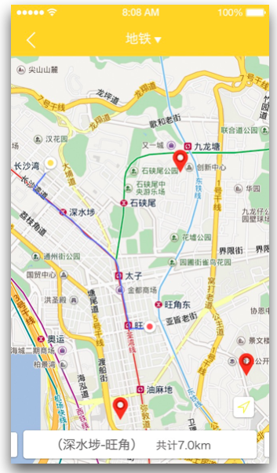

**~~Table 28. GPS-Dialog Page Elements~~**

|  |  |  |  |
| --- | --- | --- | --- |
| **~~Field Elements~~** | | | |
| ~~S/N~~ | ~~Labels~~ | | ~~Description~~ |
| ~~1~~ | ~~Enable GPS Location Service~~ | | ~~Static Label~~ |
| **~~Buttons~~** | | | |
| ~~S/N~~ | ~~Name~~ | ~~Description~~ | |
| ~~1~~ | ~~Cancel~~ | * ~~Dismiss this dialog~~ | |
| ~~2~~ | ~~Enable~~ | * ~~Turn on GPS / location service immediately~~ * ~~Or if cannot, go to Android System Preferences to let user turn it on manually~~ | |

**----- End of Document -----**